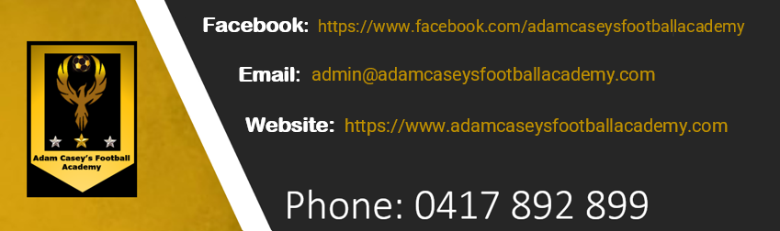

BULLYING AND HARASSMENT
ACFA aims to provide a safe and enjoyable environment for all Members participating in football. Everyone involved in our sport should be treated with respect and dignity and be free to participate without being discriminated against, harassed, bullied, or abused.
ACFA is committed to ensuring that football is an inclusive sport for all Members and that any form of Bullying and Harassment is not acceptable in our sport.
Everyone should be able to enjoy participating in football and have a safe, positive and inclusive experience that is free from any form of Bullying and/or Harassment.

Bullying and Harassment: Commitment Statement
ACFA, its affiliated Football Entities and all Members are committed to football being a sport where all Members are free and able to enjoy participating in a safe, inclusive and supportive environment. This includes a zero-tolerance policy for any form of Bullying or Harassment.
As part of this commitment, Football Entities will develop and maintain a speak up culture, where Members are able to report any complaints regarding this type of conduct or behaviour and be free from any victimisation or other adverse consequences as a result of making such a complaint.
All Members are entitled to be treated fairly and equally, and with dignity and respect at all times.

Defining Bullying and Harassment

What is Bullying?
Bullying is behaviour or conduct that involves the inappropriate use of power by one (1) or more persons in relation to another person or group of people who are less powerful or in a position of vulnerability.
Bullying may be a serious or repeated behaviour or conduct, or it may be a single incident.
Bullying may make a person feel unsafe or uncomfortable and may manifest in a variety of often interrelated forms, which may include but are not limited to:
- verbal (such as name calling; putting that person or people down; or making threats)
- physical (such as hitting or punching, kicking or spitting)
- social (such as exclusion or isolation; ostracising or alienating a person or people)
- psychological (such as spreading rumours; embarrassing someone in public or in front of their peers; hiding or damaging that person’s or people’s possession; or stalking)
- cyberbullying (using technology to target or Bully another person or group of people and may include harassment; threats; embarrassment; humiliation; or the spreading of rumours).
Bullying may cause the recipient to feel victimised, humiliated, threatened, degraded, offended or intimidated and can cause significant harm to the safety and wellbeing of the recipients. Certain types of Bullying behaviour and conduct may also be unlawful, particularly where it involves physical assault, harassment, discrimination, or if it contributes to a psychological injury.
For further information regarding Bullying, including the signs of Bullying, download the full Anti-Bullying and Harassment Policy via the link above.

What is Harassment?
Harassment is any unwelcome behaviour or conduct by a person (which may be verbal or physical) that intimidates, offends, belittles, threatens or humiliates another person. This behaviour or conduct may only have to occur once and does not have to occur on multiple occasions to constitute Harassment. Harassment does not have to be intentional, as the primary focus is on the impact of the conduct or behaviour.
As a guide, any behaviour or conduct is likely to be Harassment if a reasonable person would be likely to recognise or construe the behaviour or conduct as being unwelcome and likely to cause the recipient to feel or be offended, humiliated, threatened, or belittled.
Depending on the type of behaviour or conduct and the surrounding circumstances, Harassment may be unlawful as there are a range of Commonwealth and State / Territory legislation that protects against such behaviour or conduct. In particular, the law protects against:
- harassment that targets or has a consequential adverse impact on an individual or group of people because of a personal characteristic or attribute that is protected by State, Territory or Commonwealth anti-discrimination laws; and
- sexual harassment, which is one type of Harassment. It relates to a wide range of unwelcome behaviour and conduct that is of a sexual nature, such as but not limited to comments, remarks or innuendo and can be verbal, written, visual or physical.

Bullying and Harassment: Resources
The International Olympic Committee has developed a Consensus Statement regarding Harassment and Abuse (Non-accidental Violence) in Sport.
The “Play by the Rules” website provides helpful resources for identifying and managing bullying and harassment in sport. It includes free online training courses which are helpful for all participants, including administrators.
Sport Australia has also developed related resources to promote safe, fair and inclusive sport, which are available on the Sport Australia website. So too has the newly established government agency Sport Integrity Australia (SIA), with materials on safeguarding and member protection available from the SIA website.
ACFA will aim to provide further resources for participants, clubs and other football administrators on this page to help in eliminating any forms of bullying and harassment from our sport in accordance with the Anti-Bullying and Harassment Policy.

